**Advanced Programming (Java)**

SD-12: QAP3

Mimya Hafiz

Problem 1# High School Application Program

1. **Problem1_Demo.java Output:**

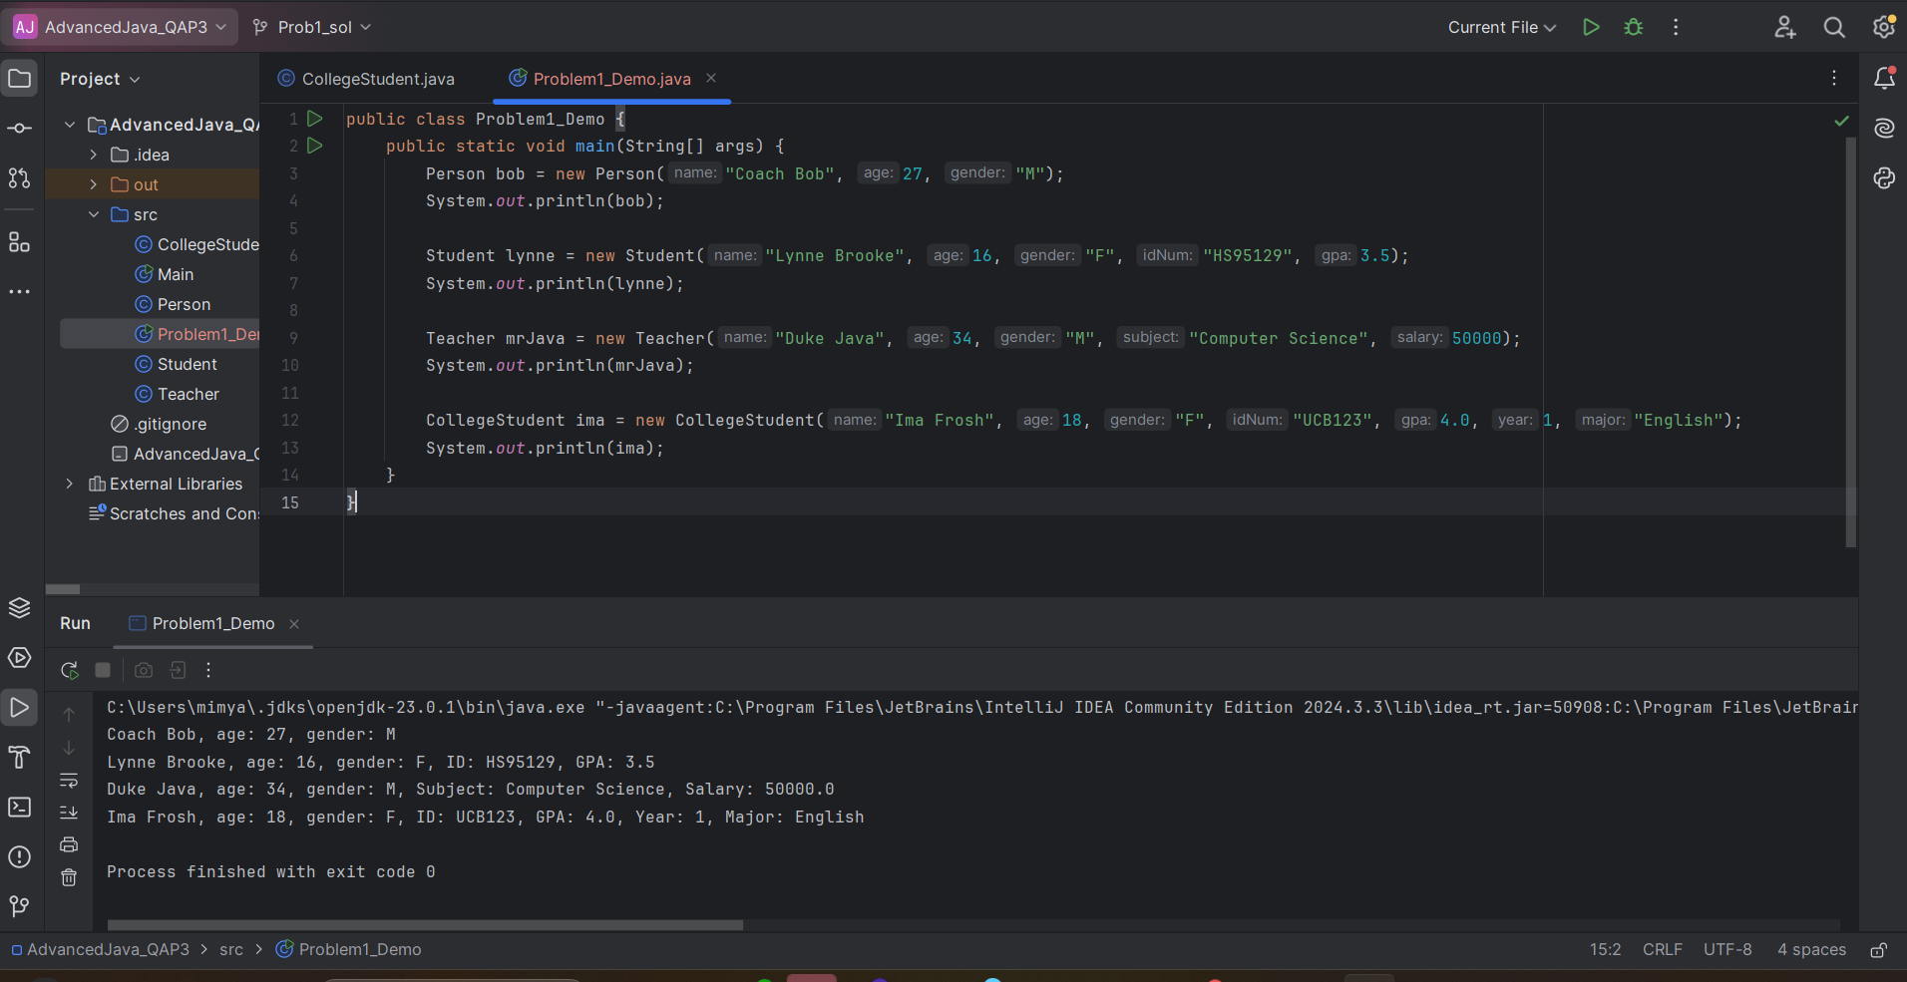

Problem 2# The Moveable Points

1. **Problem2_Demo.java Output:**

Problem 3# The Shape Abstract Class

1. **Problem3_Demo.java Output:**

**Problem 4# The Shape Abstract Class with Interface**

1. **Problem4_Demo.java Output:**

**Assessment Questions:**

1. **Time:** Approximately 8-10 hours. 1st problem took almost 3.5 hours, 2nd took 1 hour, 3rd took 3 hours, 4th took 1 hour.
2. **Used resources:** Lecture, YouTube, ChatGPT.
3. **Getting help from friends:** none.
4. **Help from instructors:** none.
5. **Difficulty:** The problems 1 and 2 were normal. Problem 3 was lengthy because of formula and so many details written in the question. Problem 4 was ok as needed to just add scaling factor with problem 3. Overall, it was a great experience for brainstorming and also helpful for my git skill improvement for the next projects.